CS 6375

ASSIGNMENT _____3_______

Names of students in your group:

Yiming Zhou

Number of free late days used: ____________________   
Note: You are allowed a **total** of 4 free late days for the **entire semester**. You can use at most 2 for each assignment. After that, there will be a penalty of 10% for each late day.

Please list clearly all the sources/references that you have used in this assignment.

1.1

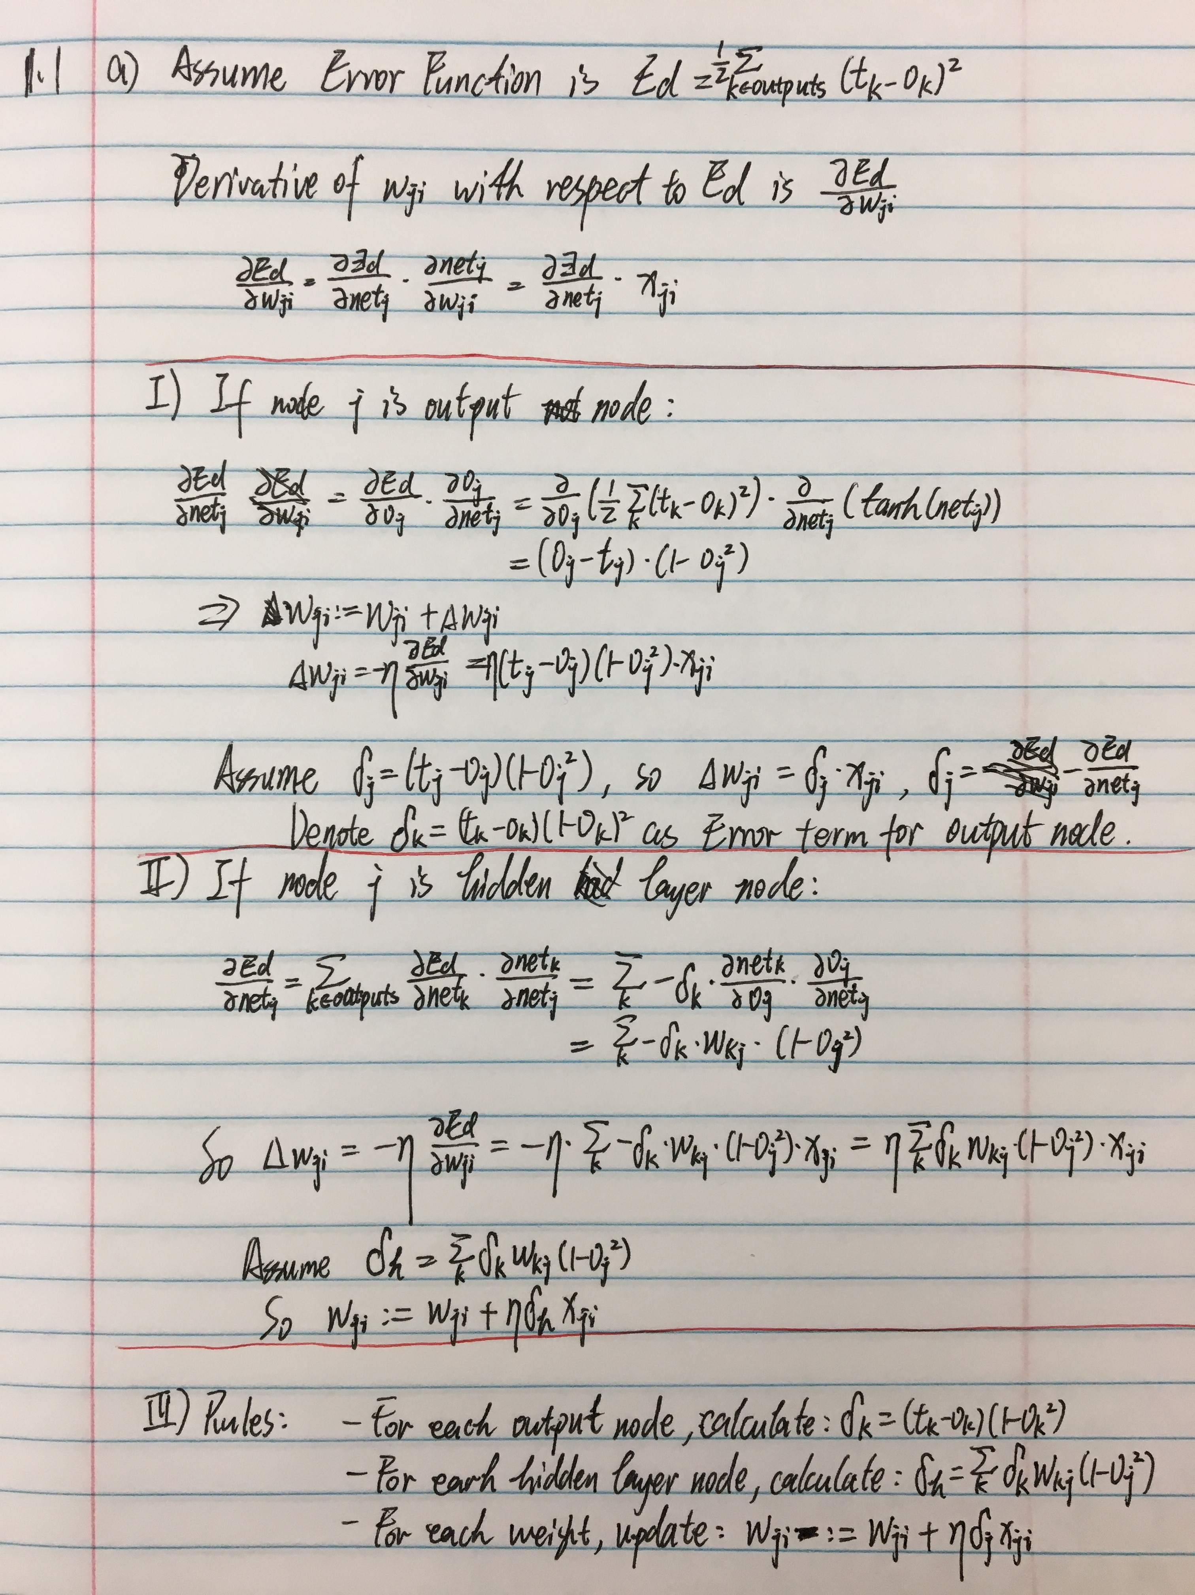

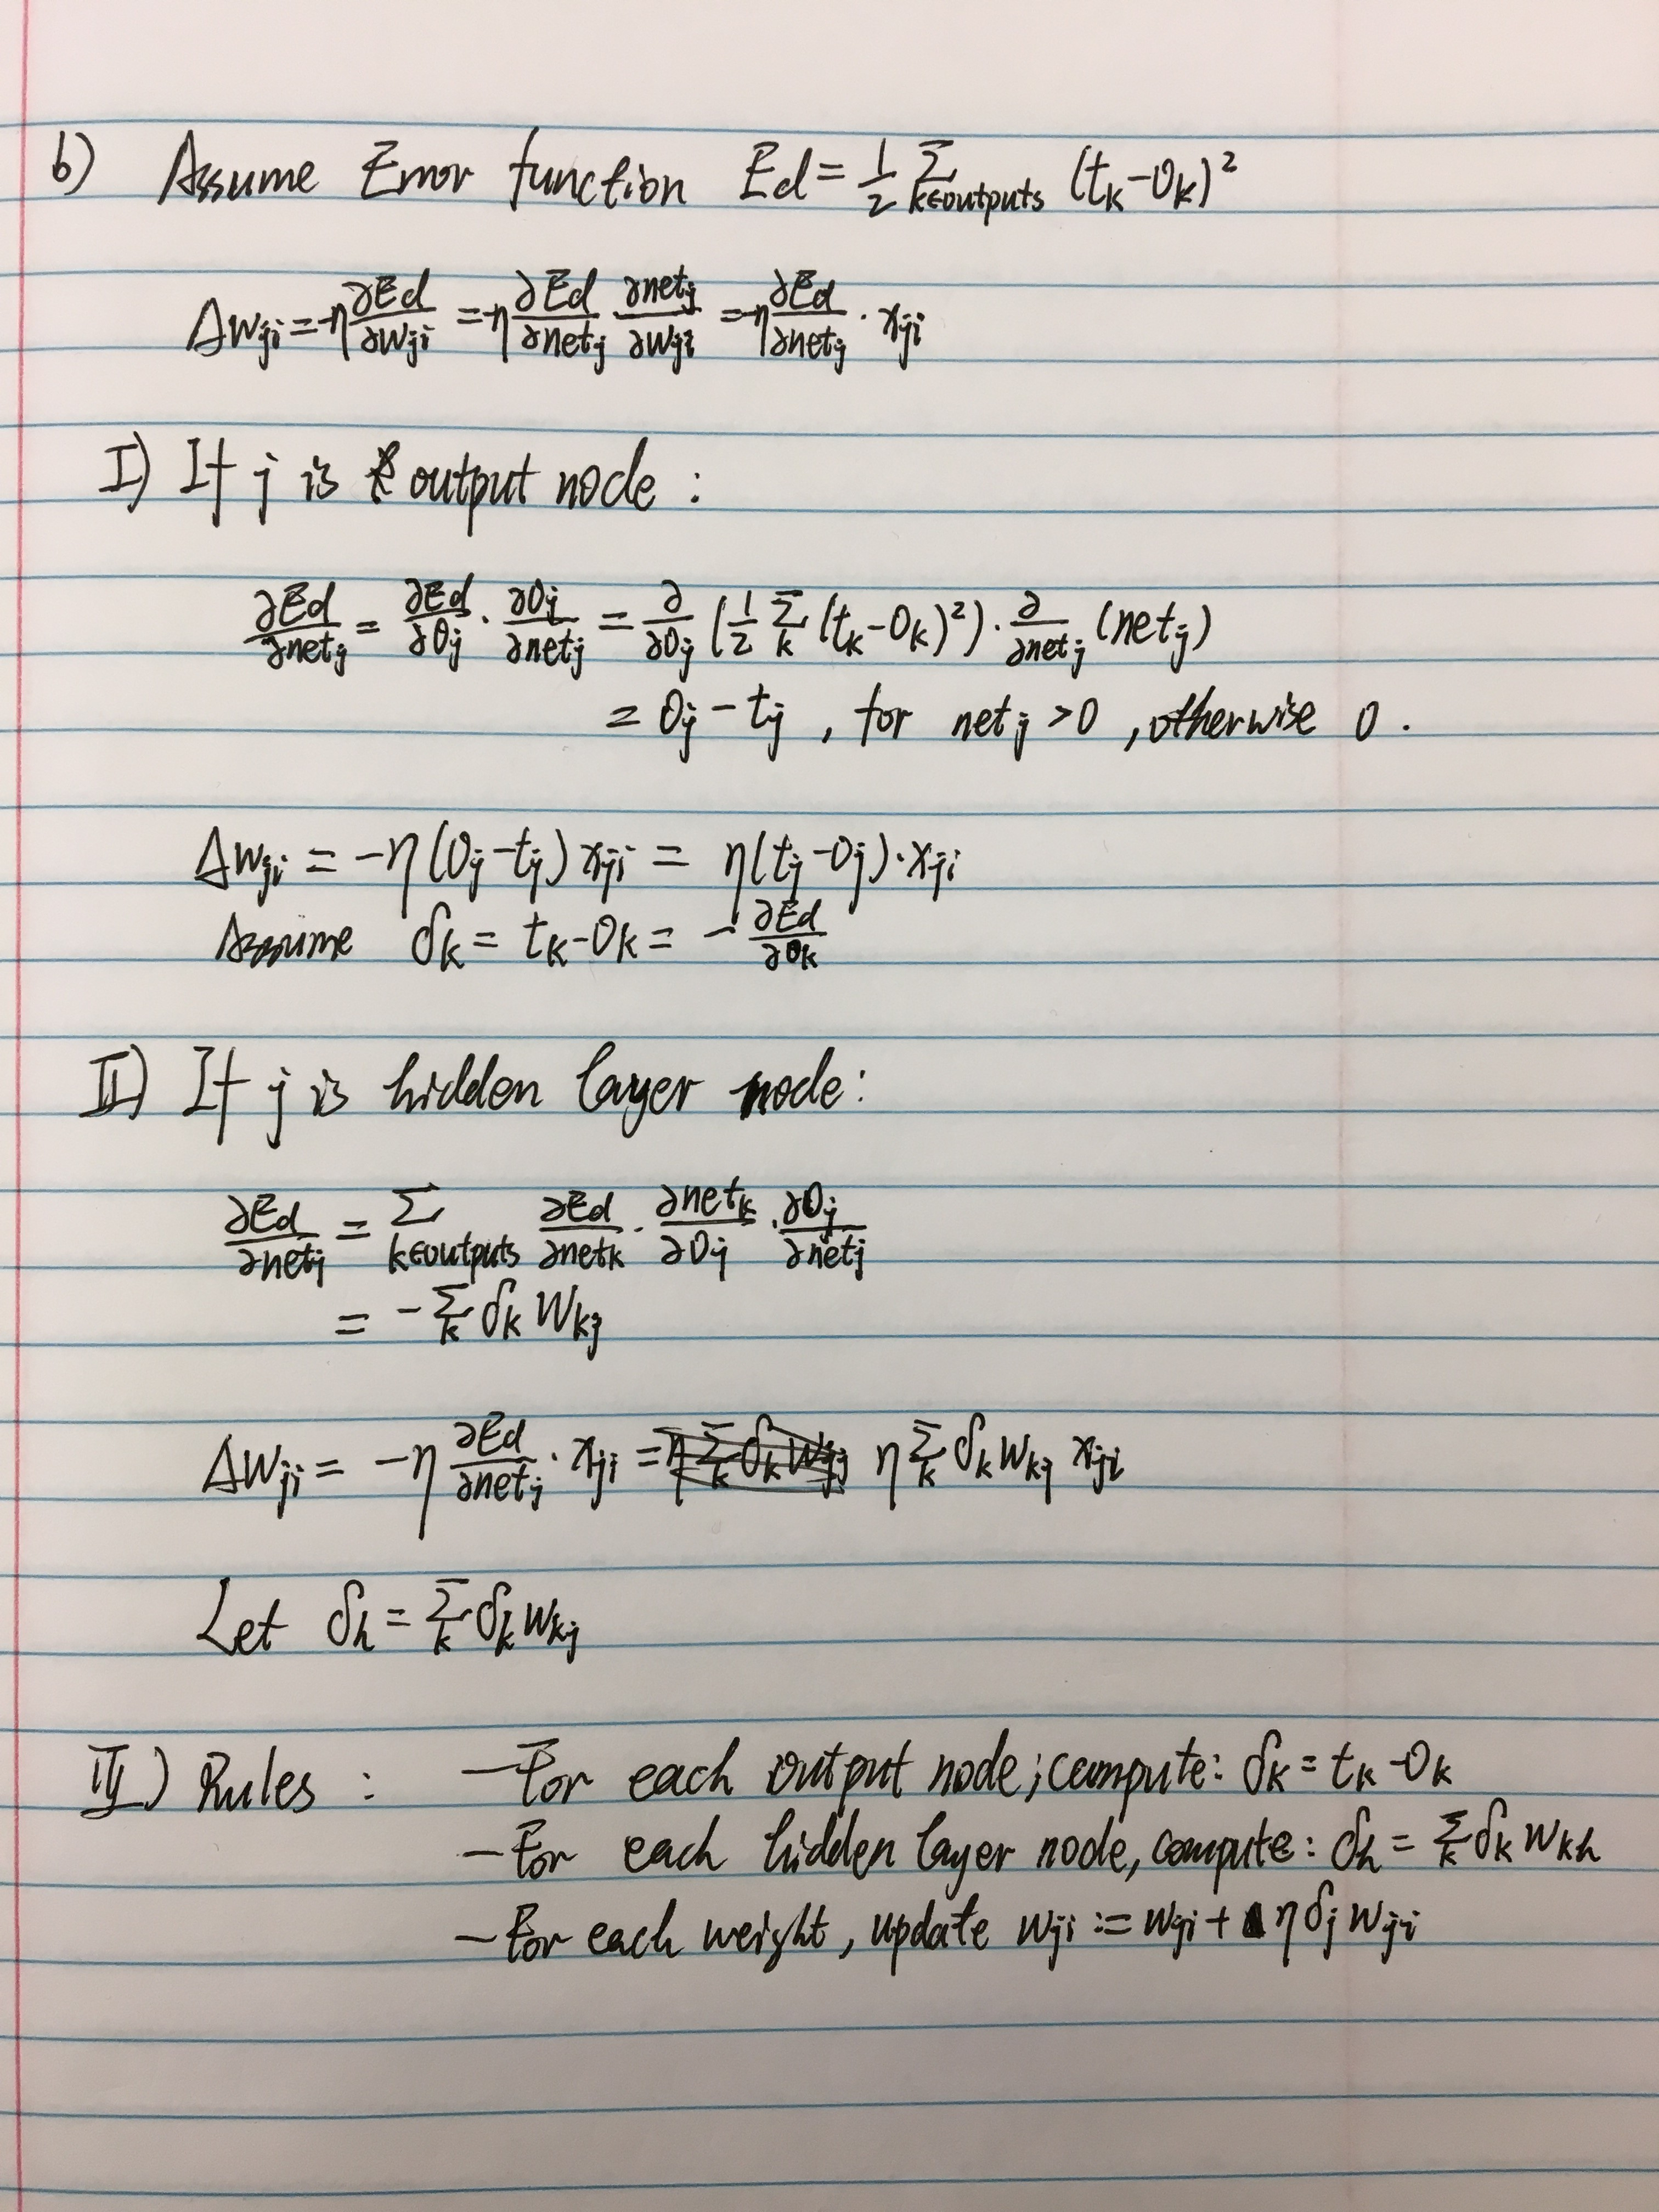

1.2

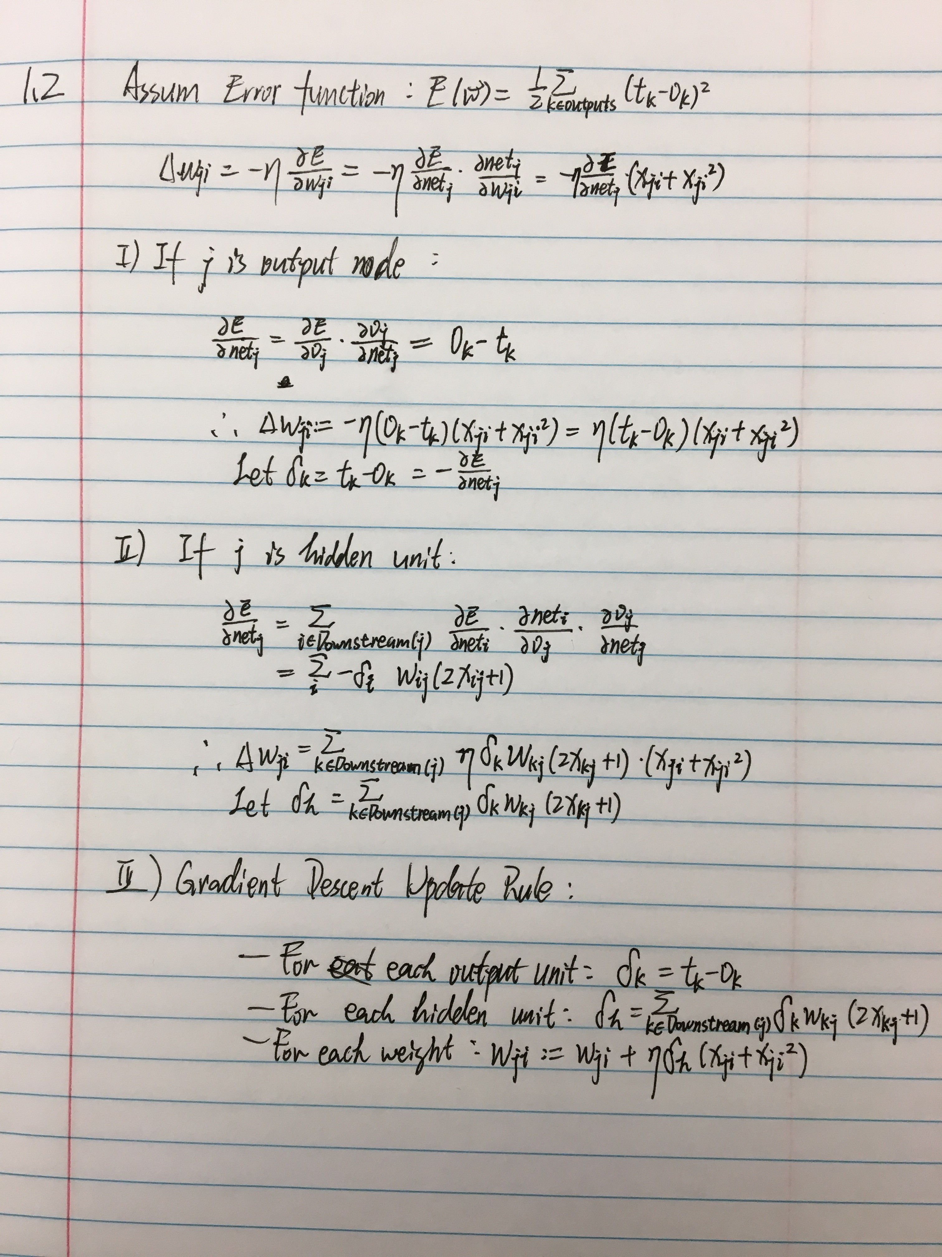

1.3

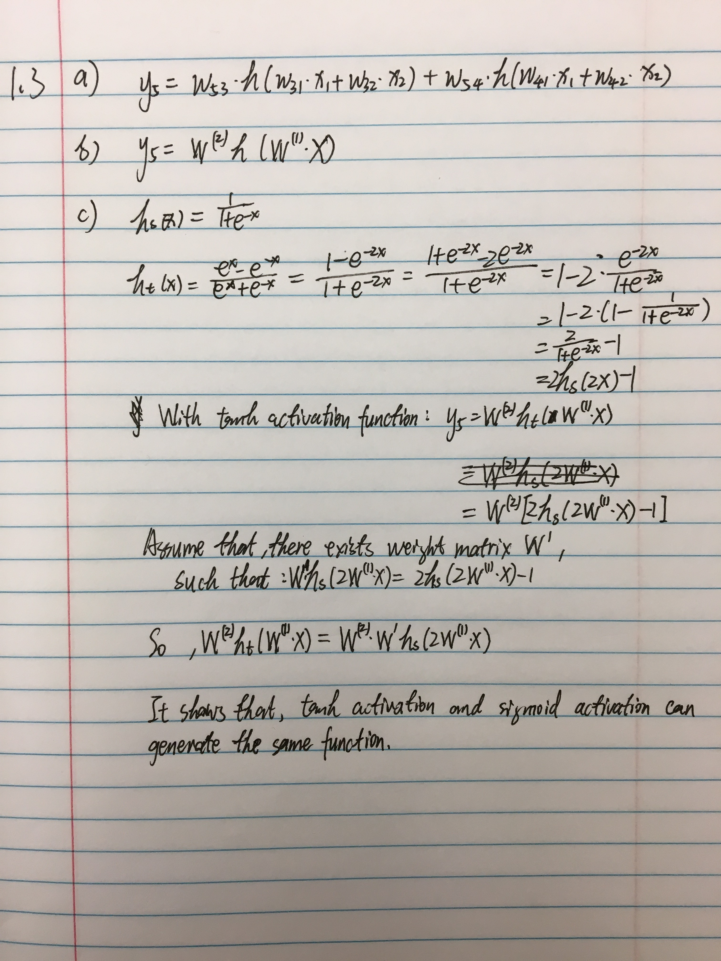

1.4

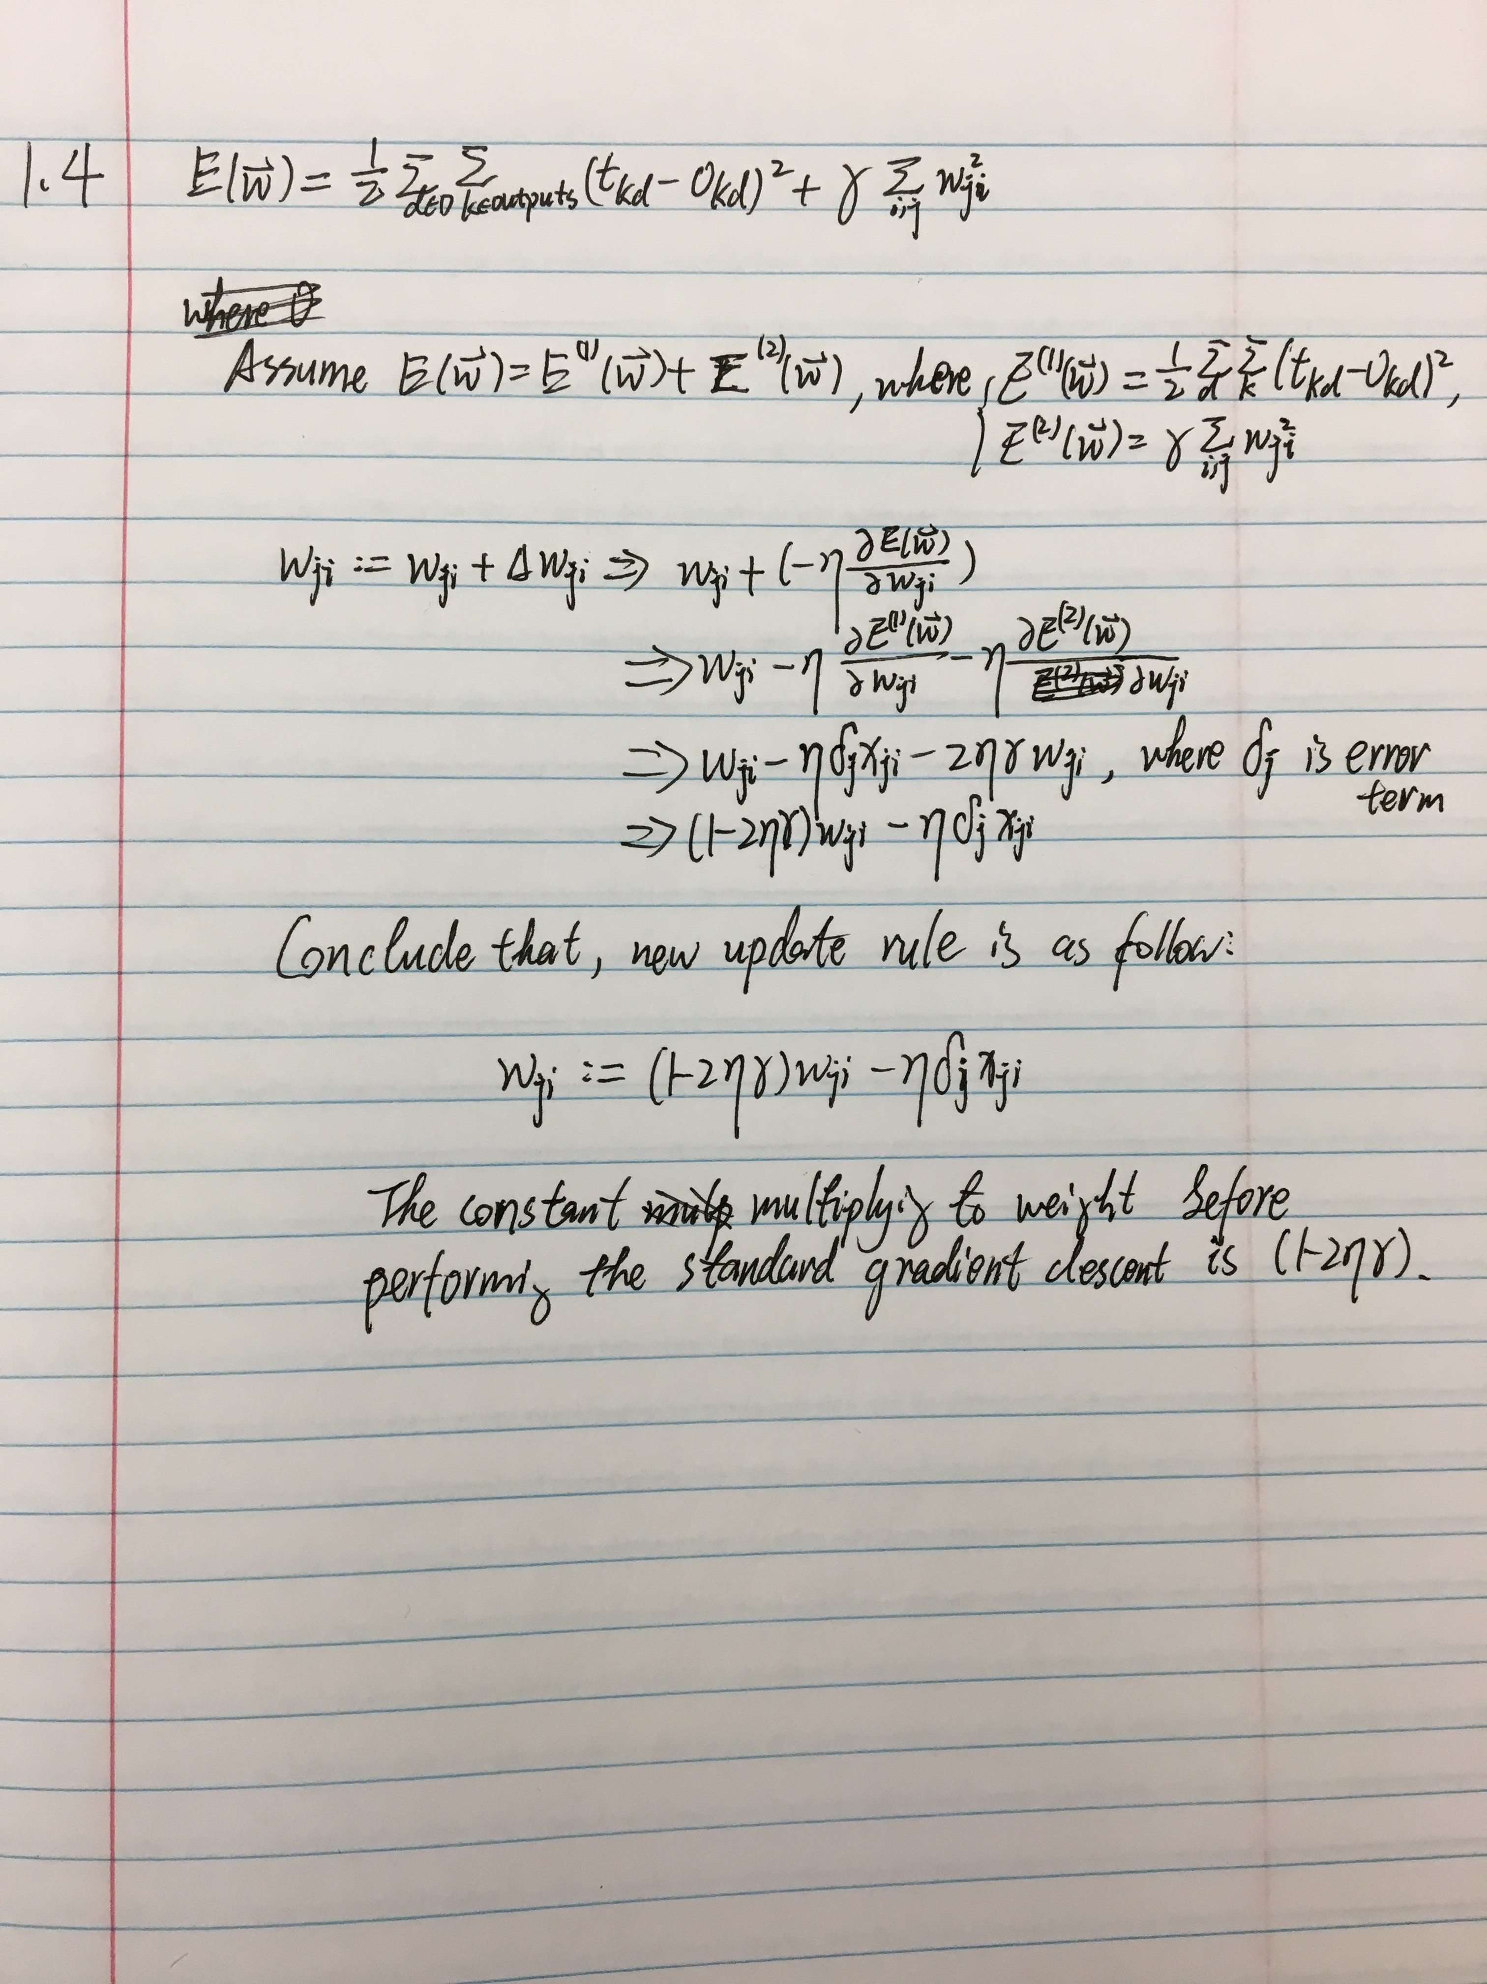

**2、**

A) Result

Fig 2.1 illutrates results of ANN model’s performance on the 4 datasets on different activation function. Parameters are: hidden layer 1’s units: 20; hidden layer 2’s units: 10; max_iteration: 1000; learning_rate: 0.2.

|  |  |  |  |
| --- | --- | --- | --- |
| Total_Error/Avg_Error | **Sigmoid** | **Tanh** | **ReLU** |
| **train.csv** | 0.1097/0.0274 | 0.5008/0.1252 | 0.7500/0.1875 |
| **Iris** | 0.2558/0.0017 | 25.0000/0.1667 | 31.2500/0.2150 |
| **Car_evaluation** | 73.8882/0.0475 | 1220.0556/0.7061 | 305.2222/0.1766 |
| **Census_income** | 3920.5000/0.1204 | 3920.5000/0.1204 | 3920.5000/0.1204 |

Fig 2.1 Results of ANN model on 4 datasets with different activation function

B) Summation

According to this result, sigmoid function as activation function performs the best. Some average errors are still high, larger than 0.1. Since output or preprocessed labels are numeric ranging from 0 to 1 or –1 to 1, average errors larger than 0.1 means that the ANN model doesn’t fit the dataset well. Among the three activation functions, I think sigmoid function performs best in this problem with its lowest error measurement shown above. Reasons are:

1) Tanh function is more slope, vanishing problem is more likely to happen, especially in these datasets.

2) Relu function doesn’t respond to value lower or equal to zero.

C) Assumptions

Here are assumptions in my model:

1) Each hidden layer as well as output layer use the same activation function

2) Output of this model is a single numeric value, even for multiclassification problem, which means, accuracy measurement in this situation is not clear.

3) Cost function is Euclidean distance function.